EXPERIMENT – 13

Study of Phishing Attacks Using Z-Phisher (Open-Source GitHub Tool) in Kali Linux

Aim
To study phishing attack concepts using the Z-Phisher open-source framework in Kali Linux in order to understand social-engineering threats, user behavior exploitation, and preventive security measures.

Software Requirements
- Host Operating System: Windows / Linux / macOS
- Virtualization Software: Oracle VirtualBox
- Guest Operating System: Kali Linux
- Study Tool: Z-Phisher (Open-Source GitHub Framework – Educational Use)
- System Requirements:
  - RAM: Minimum 4 GB (8 GB recommended)
  - Disk Space: Minimum 30 GB
  - Processor: Intel/AMD with Virtualization support

Introduction
Phishing is a social-engineering attack where attackers trick users into revealing sensitive information such as usernames, passwords, or OTPs by impersonating trusted entities.
Z-Phisher is an open-source educational framework that demonstrates how phishing pages are structured and how attackers exploit human trust rather than software vulnerabilities.
Studying phishing attacks in a controlled Kali Linux environment helps learners understand attack workflows, risks, and the importance of security awareness and defense mechanisms.

Procedure

Step 1: Start Kali Linux Virtual Machine
- Open Oracle VirtualBox.
- Start Kali Linux.
- Log in using Kali credentials.

Step 2: Study the Z-Phisher Framework
- Visit the Z-Phisher GitHub repository (read-only study).
- Review documentation to understand:
  - Types of phishing templates
  - Social-engineering techniques used
  - Ethical usage warnings

Step 3: Understand Phishing Attack Workflow
- Analyze how fake login pages mimic legitimate websites.
- Observe how users are tricked into entering credentials.
- Study the role of URL masking and trust exploitation.

Step 4: Controlled Demonstration (Simulation Only)
- Perform a local, consent-based simulation using dummy accounts.
- Observe how phishing pages appear to users.
- Analyze user response behavior (no real credentials used).

Step 5: Identify Security Risks
- Credential theft
- Identity compromise
- Financial fraud
- Privacy violations

Step 6: Study Prevention Techniques
- User awareness and phishing education
- Browser security warnings
- Two-factor authentication (2FA)
- Email and URL filtering
- HTTPS and domain verification

Output
- Clear understanding of phishing techniques and attack flow.
- Identification of social-engineering risks.
- Screenshots and notes recorded for academic reference.
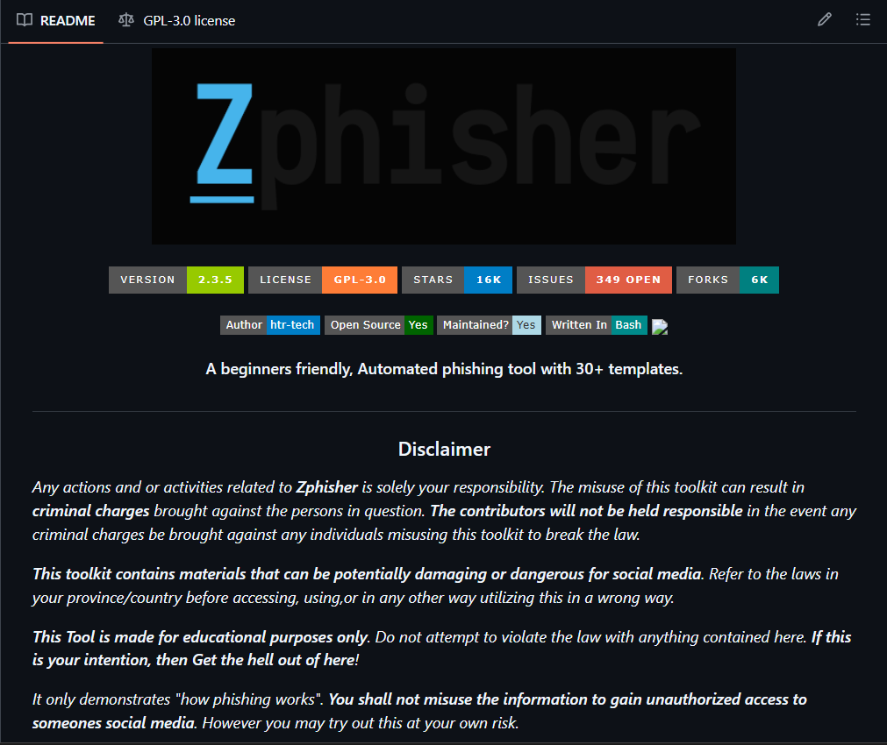
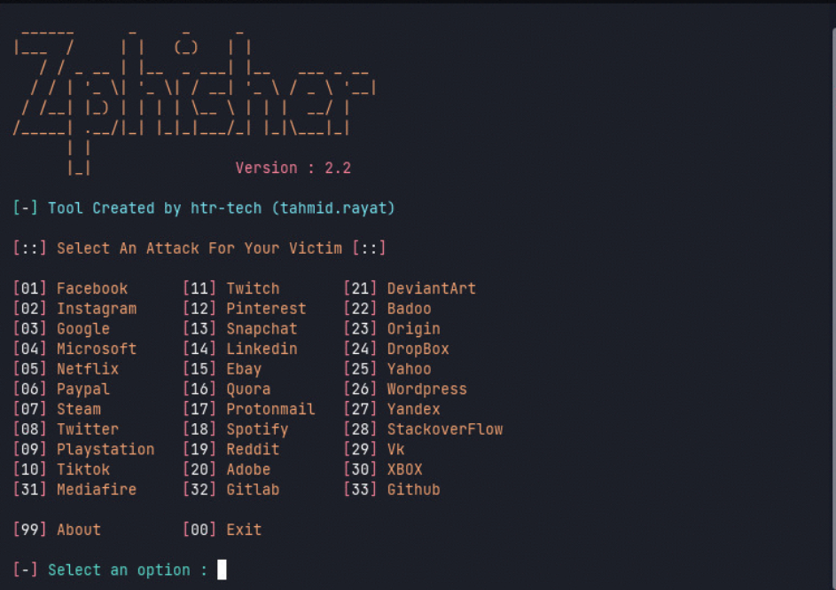

Result
The study of phishing attacks using the Z-Phisher framework was successfully completed in Kali Linux.
This experiment improved understanding of social-engineering threats and emphasized the importance of user awareness and defensive security practices.

Reference
https://www.kali.org
https://github.com

